**TABLEAU PROJECT**

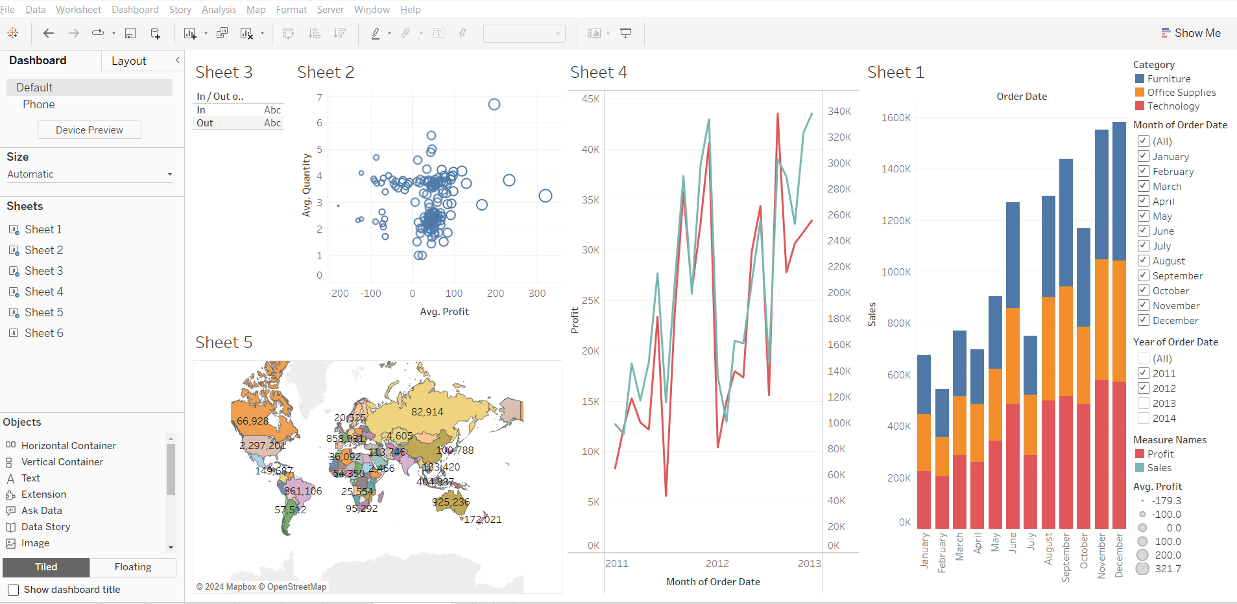

Source file link:<https://public.tableau.com/app/profile/kokila.r3624/viz/Tableauproject_17104866804360/Dashboard1?publish=yes>